How to prepare your extended abstract for AWTEC 2026 (Maximum two pages inclusive)

First A. Author, Second B. Author, and Third C. Author

Abstract—These guidelines detail the requirements for preparing extended abstracts for AWTEC 2026. Using Microsoft Word 2010 or later, use this document as your template. Note that paper titles should use sentence case, capitalizing only the first letter and any proper nouns; avoid capitalizing every word or using all uppercase letters. This abstract section must be a single paragraph, strictly between 150 and 250 words. Ensure you edit your text to meet this word limit. Finally, this abstract section should not contain displayed mathematical equations or tabular material, and it must be grammatically correct and easy to read.

Keywords—Enter at least three keywords or phrases alphabetically, separated by commas.
- Introduction
This document serves as your template for Microsoft Word 2010 or later. If you are viewing a paper or PDF version, please download the AWTEC_WordTemplate.docx file from the AWTEC website to prepare your extended abstract. A LaTeX package, including style and sample files, is available on the same page. This template was modified from the EWTEC paper template file.
AWTEC also uses an A4 page size with a column width of 86 mm and a 6 mm column spacing. Margins are set at: Left/Right (16 mm), Top (22 mm, including header), and Bottom (14 mm). The header height is 10 mm.
When using the Word template, either type directly into the sections or paste your content as plain text and then apply the appropriate styles. All required styles are prefixed with “AWTEC_” (the current style is "AWTEC_Normal," for example). To use a style, highlight the section and select the corresponding name from the style menu. This action will automatically adjust the fonts and line spacing. Do not manually change font sizes or line spacing to fit more text. Use italics for emphasis; do not underline.
- Materials and Methods
All materials and methods used in the work must be stated clearly. Subtitles should be used when necessary.
Sponsor and financial support acknowledgment: For example, “This work was supported in part by the NSTC under grant...”
The next few paragraphs should contain the authors’ current affiliations, including current address and e-mail. For example:
F. A. The author is a professor with the Department of Mechanical and Mechatronic Engineering and the Center for Ocean Energy System at the National Taiwan Ocean University, Keelung 202301, Taiwan (e-mail: f.a.author@ntou.edu.tw).
S. B. Author was at …. He is now at … (e-mail: s.b.author@domain.tld).
T. C. Author is with the Department of Physical Oceanography, CICESE, Carretera Ensenada-Tijuana 3918, Ensenada, Baja California, México (e-mail: t.c.author@domain.tld).
- Subsection
Section and subsection headings should have only the first letter and proper nouns in capitals, not each word capitalized or all uppercase.
- Equation
Number equations consecutively with equation numbers in parentheses flush with the right margin, as in (1).
 | $$P=\frac{1}{2}ρU^{3}A$$ | (1)
where the symbols in your equation need to be defined before the equation appears or immediately following.
- Results and Discussion
Place your results and discussion content here. Authors must ensure that all elements, including tables, graphics, and equations, are sized to fit entirely within the column margins. All figures, graphs, and tables must be numbered sequentially. As examples of acceptable sizing and captioning, Fig. 1 illustrates the testing of a point absorber wave energy converter system developed by the Industrial Technology Research Institute (ITRI), and Table 1 lists common physical quantities or variables, the symbols used to represent them in equations, and the standard Units of measurement.

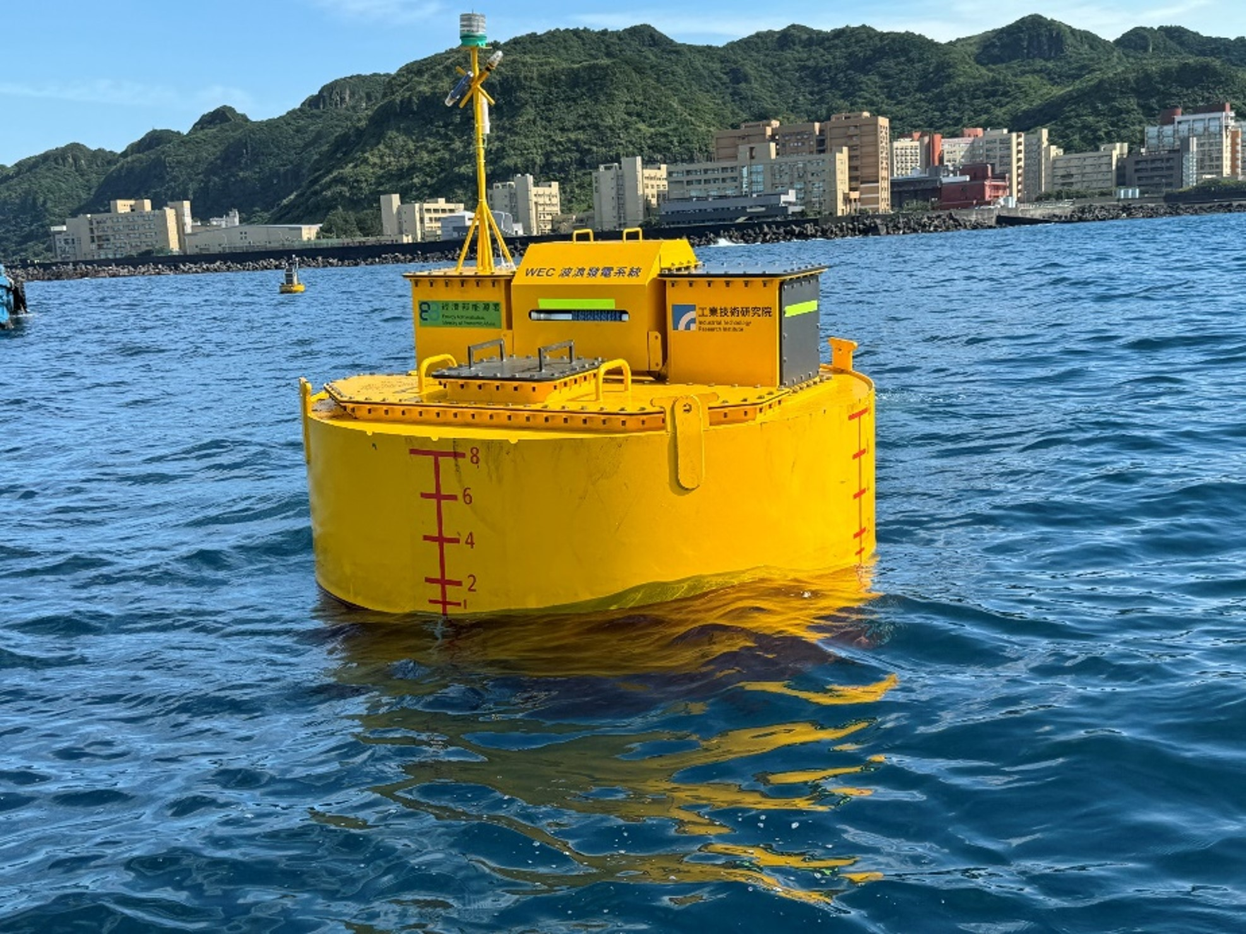
Fig. 1: A point absorber wave energy converter system tested by the Industrial Technology Research Institute outside of Keelung Harbor. Conclusion. Note that there is a period after the figure number, followed by two spaces. It is good practice to explain the significance of the figure in the caption.
Table I: Example variables and units
Symbol | Quantity | Unit
U | Flow speed | 1 m/s = 0.514 knª
p | Pressure | Pa
μ | Dynamic viscosity | Pa·s
ν | Kinematic viscosity | m²/s
L | Distance | 1000 m = 1 km = (250/463) nmiª
E | Energy | 1 kJ = 0.27 kWh
a | Acceleration | m·s⁻²
F | Force | N
P | Power | W
M | Mass | 1000 kg = 1 t
Q | Flow rate | m³/s
Vertical lines in tables are deprecated. Statements that serve as captions for the entire table do not need footnote letters.
- References Guideline
In all references, the given name of the author or editor is abbreviated to the initial only and precedes the last name [1]. Use them all; use et al. only if names are not given [2]. Abbreviate conference titles. When referencing a patent, provide the day and the month of issue or application. References should include enough information for the reader to find the original source. Do not combine references. There must be only one reference with each number [3]-[5]. If a URL is included with the print reference, it can be added at the end of the reference [6].
Capitalize only the first word in a title, except for proper nouns and element symbols. For papers published in translation journals, please give the English citation first, followed by the original foreign-language citation.
Be sure to apply the AWTEC_ReferenceItem style to your list of references. If using reference software, choose the IEEE Transactions numbered style. Balance columns on the final page using a column break.
- Conclusion
Place 3 to 4 lines here. A conclusion might elaborate on the significance of the work or suggest potential applications and future extensions.

Acknowledgment
Use the singular heading even if you have many acknowledgments. Avoid expressions such as “One of us (S.B.A.) would like to thank ... .” Instead, write “F. A. Author thanks ... .” Sponsor and financial support acknowledgments are placed in the unnumbered footnote on the first page, not here.

References
- G. I. Taylor, “Tidal Oscillations in gulfs and rectangular basins,” Proceedings of the London Mathematical Society, vol. 20, pp. 148-181, 1919.
- G. Aad et al., “Combined Measurement of the Higgs Boson Mass in pp Collisions at √s = 7 and 8 TeV with the ATLAS and CMS Experiments,” Phys. Rev. Lett., vol. 114, no. 19, p. 191803, May 2015. [Online]. Available: https://link.aps.org/doi/10.1103/PhysRevLett.114.191803
- J. Falnes and J. Lovseth, “Ocean wave energy,” Energy Policy, vol. 19, no. 8, pp. 768–775, 1991.
- I. P. Castro, “Wake characteristics of two-dimensional perforated plates normal to an air-stream,” Journal of Fluid Mechanics, vol. 46, no. 3, pp. 599—-609, 1971.
- E. M. Evans, “Tidal stream energy,” Ph.D. dissertation, Plymouth Polytechnic, 1987.
- A. Babarit, J. Hals, M. J. Muliawan, A. Kurniawan, T. Moan, and J. Krokstad, “Numerical benchmarking study of a selection of wave energy converters,” Renewable Energy, vol. 41, pp. 44–63, 2012. [Online]. Available: http://www.sciencedirect.com/science/article/pii/S0960148111005672

